**The problem we encounter :**

**Basic Topic Name in sensor node free(phone).**

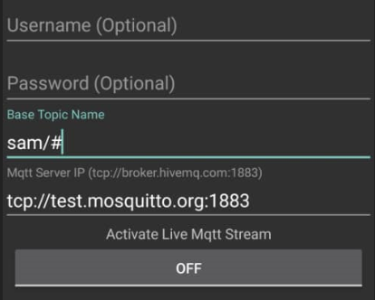**(Wrong)**

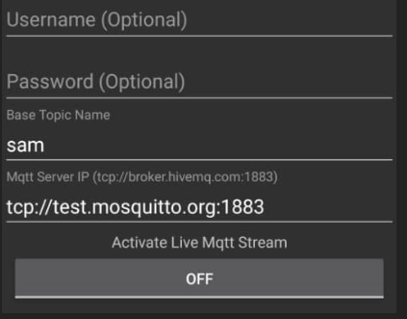**(Correct)**

**Find the code behind entry.**

1. Go to get pre-filled link.
2. View source page on that page.
3. Then ctrl+f and find entry word.

